StollyStructs

A plugin that helps to visualise and label datastructures from within OllyDbg.
The idea is simple. When you want to examine a data structure that’s being used in your target now you have to look up the definition of the data structure in MSDN and start counting the bytes to look at the structure member you are interested in.
Very tedious work☹. StollyStructs should bypass all this.
It consists of a plug-in dll “stollystruct.dll” and a data file “stollystructs.ini”
I parsed the windows.inc file from the masm library to build up the data file and added a few of my own. Currently there are about 1200 structure definitions inside the data file, so chances are that the one you are interested in is in there. ☺

Installation

Copy StollyStructs.dll to your Olly plug-in directory and StollyStructs.ini to the OllyDbg.exe directory.

How to use

When reversing a target and you want to examine a data structure you only have to right-click Olly in the stackdump or in the datadump window and select “Structure”.
A new window will pop up where you have to specify the starting address, type and optionally an instance name for the data structure.

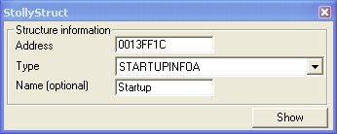

And that’s it. StollyStructs should now popup a new Olly windows where you can examine the structure information.

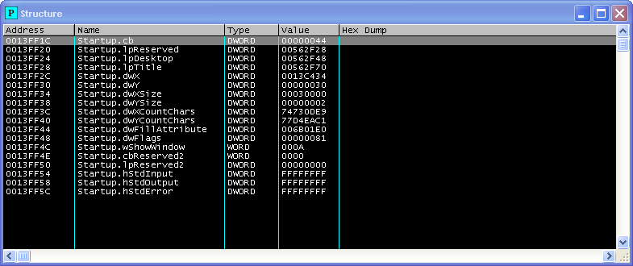

1, 2 and 4 bytes value are shown in the value column. Other datasizes are shown in the hexdump (little indian) format. The hexdump is limitted to 128 bytes.

Extra

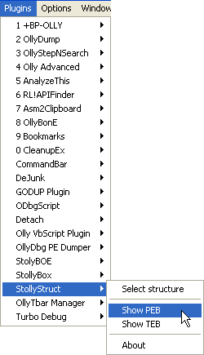
I coded a quick reference to the TEB and the PEB structure. If you are interrested in anything in there ☺

